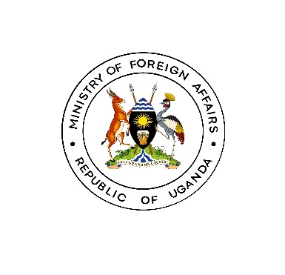

**MEDIA RELEASE**

*Dubai: February 13th 2024*

**UGANDA SIGNS MOU WITH UAE ON EXPERIENCE EXCHANGE IN GOVERNMENT DEVELOPMENT AND MODERNISATION**

Uganda and UAE have signed a Memorandum of Understanding (MoU) on Experience exchange in Government Development and Modernization. The MoU was signed on 13th February 2024 on the margins of the ongoing World Governments Summit taking place in Dubai.

Gen. Odongo Jeje Abubakhar, Minister of Foreign Affairs signed the MoU on behalf of the Government of Uganda while H.E. Mohammad Abdullah Al Gergawi, Minister of Cabinet Affairs signed on behalf of the UAE.

The purpose of the MoU is to develop joint efforts aiming to promote institutional capabilities and enhance governance in the field of developing government work, building institutional capacities and skills for the future. The Ministry of Public Service in Uganda will be the implementing partner and will collaborate with the UAE counterpart to coordinate and facilitate cooperative activities under the MoU. These include but not limited to Strategic Human Resource Management, Public Service Excellence and Innovation, Professionalization of cadres in the Public Service etc.

The signing of the MoU marks another milestone in enhancing the relations between Uganda and the UAE. The two countries enjoy cordial and mutually beneficial relations, characterized by several MoU's signed in various fields and exchange of high-level visits. The signing of this additional MoU is testament to the commitment by the leaders of the two countries to continue fostering cooperation in not only existing sectors but also new fields.

Gen. Odongo expressed appreciation to the government and people of UAE for the traditional friendship and for supporting Uganda’s transformation journey through investments in the different sectors of the country's economy. He underscored Government's commitment to continue facilitating and protecting investments. In addition, he observed that in recent years, there has been a marked increase in the Ugandan diaspora in UAE estimated at over 150,000 and thanked the government of UAE for hosting and offering them opportunities.

Gen. Odongo is representing H.E the President at the 2024 edition of the World Governments Summit taking place from 12-14 February 2024 under the theme of 'Shaping Future Governments' where the discussions involve governments, international organizations, thought leaders, and private sector leaders from around the globe to exchange ideas and identify innovative solutions for future challenges. **END.**