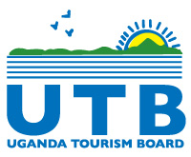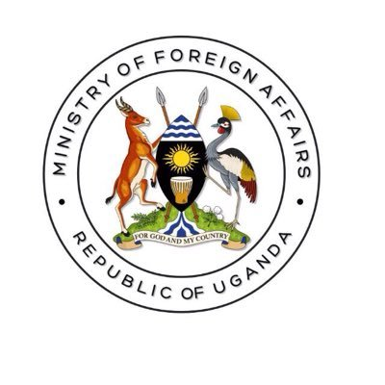

**PRESS RELEASE**

**MINISTRY OF FOREIGN AFFAIRS AND UGANDA TOURISM BOARD TO JOINTLY PROMOTE DESTINATION UGANDA IN KEY TOURISM SOURCE MARKETS.**

**Saturday, 1st July 2023**

In the bid to position Uganda as a preferred tourism destination, the Uganda Tourism Board and the Ministry of Foreign Affairs (MOFA) will jointly promote the destination under the flagship Explore Uganda brand through the High Commissions and Embassies around the world as part of the government’s efforts to create awareness of the destination’s tourism potential.

Both UTB and MOFA officials agreed to align annual work plans through the implementation of a joint international marketing strategy, support on the issuance of crisis communications, collaboration with diaspora associations and the promotion of investment in Uganda’s hospitality industry.

The strategic interventions were raised during the two-day destination training and familiarization trip at the Chimpanzee Sanctuary at the Ngamba Island in Koome sub county, Mukono district. During the excursion, the diplomats were briefed on the country’s marine tourism potential on Lake Victoria and River Nile, the remarkable strides registered in the conservation of the endangered primates and tourism development potential across the country.

The Ministry of Foreign Affairs will also ensure that the Foreign Service Officers are exposed to more tourism attractions; adventure, faith, film and lifestyle tourism to attract travellers in to Uganda as part of their services.

Speaking on behalf of UTB, Senior Marketing Officer, Mr. Daniel Irunga, added that the Explore Uganda fam trip to the Ngamba Island provided a first-hand experience and knowledge to the diplomats who will be deployed across the world. He added that more similar trainings and fam trips will be rolled across the strategic Ministries, Departments and Agencies, with the crosscutting mandate of tourism promotion.

In return, both UTB and the MDAs will align their annual work plans with strategic focus on the Explore Uganda brand roll out and its objective of increased tourism arrivals and revenue.

During the fam trip, the Ministry of Foreign Affairs Head of Delegation, Mr. Agama Anthony/Minister Counsellor reiterated the need for government to promote national pride and patriotism through the domestic tourism campaigns and diaspora coordination. He added that Uganda could tap into the third and fourth generation of Ugandans across the world through consistent coordination of the diaspora associations.

Mr. Agama further advised the Uganda Tourism Board and the Uganda Investment Authority to work with the Ministry of Foreign Affairs, and tap into the diaspora investment funds for tourism promotion and development. Regarding, immigration, the Head of delegation implored the Ministry of Internal Affairs to review the existing laws on the registration of second and third generation of Ugandans born outside Uganda and to reach them through timely consular service delivery.

Over 40 diplomats attended the two-day training and familiarization trip ahead of their four-year tour of duty in Uganda’s missions abroad.

**About Uganda Tourism Board**

“Uganda Tourism Board (UTB) is a statutory organization established in 1994. UTB is mandated to promote and market Uganda domestically, across the region and internationally, promote quality assurance in tourist facilities through training, grading and classification, promote tourism investment, support and act as liaison for the private sector in tourism development. The broader goals of the Board are to increase the contribution of tourism earnings and GDP; enhance Uganda's competitiveness as an international tourism destination; and increase Uganda's share of Africa's and World tourism market. UTB aims to create inclusive opportunities for the tourism sector through market transformation.

**For More Information**

**Email: gessa.**[**simplicious@utb.go.ug**](mailto:simplicious@utb.go.ug)